**Step 1:**

**Lets checkout what’s going on:**

Create a new Quotation or Sale Order

Click on “Add an Item”

Enter the Product (That has many Attributes and Values)

In this window, Open : Order Lines

Right at the bottom is the default auto description.

Shown Below is an example of the Existing Description Field, that includes the “Internal Reference (default_code)/ Product Name / (and all the attribute values)

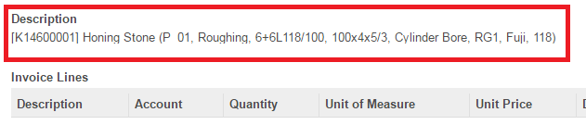

Figure1

The First thing we need to do is to make a small modification inside the “Product.py” File located inside the” addons/product” folder.

This modification is to include the “Product Attribute Names” next to the respective “Attribute Values”

After this modification, this is what we expect to see.

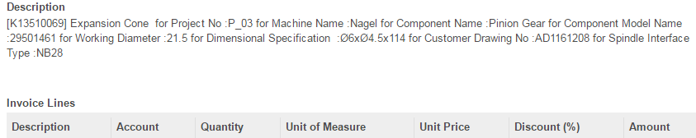

Figure2

(I have included a screen shot of my product Attribute page, so you can see the different attributes that I have on my list – Figure3)

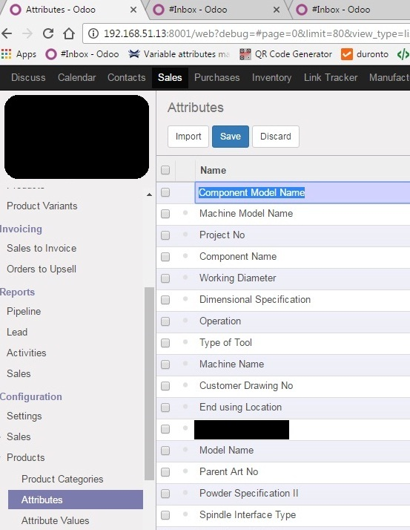

Figure3

**Step 2:**

**Lets Start :**

**Editing the product.py File (addons/product/product.py):**

**[** Note: Please **Backup your Product.py** file (addons/product/product.py) before you make any changes to it. So, if you encounter any errors, you always have a copy of the Original **]** Refer Screenshot below (Figure4)

CODE:

**This is the area of the Code that we are looking for (Marked in Red):**

for product in self.browse(cr, SUPERUSER_ID, ids, context=context):

**variant = ", ".join([v.name for v in product.attribute_value_ids])**

name = variant and "%s **(%s)"** % (product.name, variant) or product.name

sellers = []

if partner_ids:

sellers = [x for x in product.seller_ids if (x.name.id in partner_ids) and (x.product_id == product)]

**These are the changes we need to do (Marked in Green):**

for product in self.browse(cr, SUPERUSER_ID, ids, context=context):

**variant = ''**

**for item in product.attribute_value_ids:**

**variant += " for "+str(item.attribute_id.name)+' :'+item.name)**

name = variant and "%s **%s**" % (product.name, variant) or product.name

sellers = []

if partner_ids:

sellers = [x for x in product.seller_ids if (x.name.id in partner_ids) and (x.product_id == product)]

Now, please **Save this file.**

Screenshot:

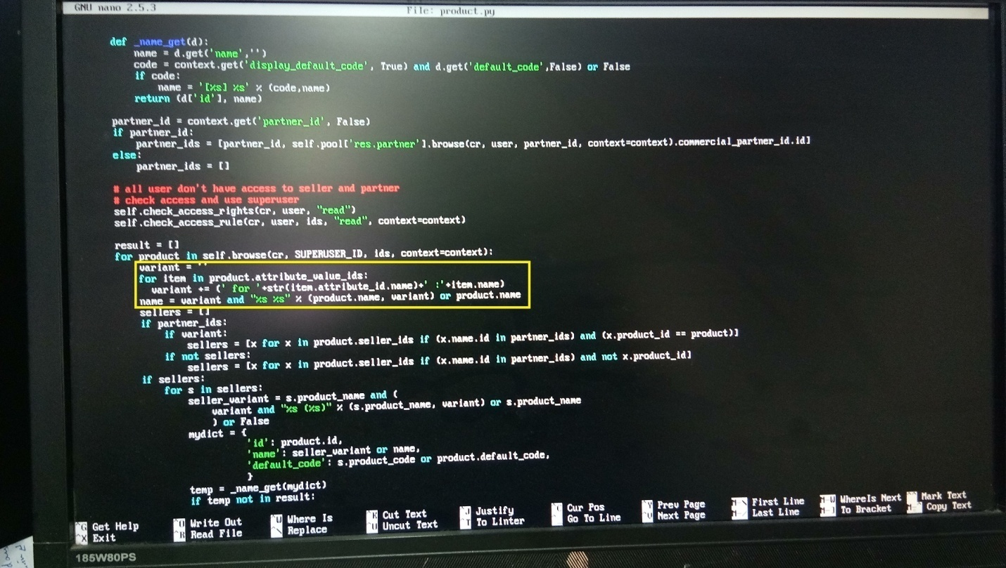

Figure4

**Step 3:**

**Editing the sale_desc.py File (addons/sale_desc/models/sale_desc.py):**

We need the details of your **Product Attributes**:

Please refer the screen shot included earlier in this document (Figure3) and compare it to the script below. You will know what to replace. Please see how I have my Product Attributes in the code. Please replace these with your Attributes that you would like in your description.

I have written the code for a maximum of 6 attributes. If you have just 3, replace for just 3 and leave the rest of the code un-altered.

**[** Note: Please be careful during this step, even an extra space anywhere will not yield you results.**]**

Refer below for a screenshot (figure5)

**Backup your sale_desc.py file**, so you have a copy of the original.

Now, edit your sale_desc.py file that you can find inside the folder “models” of this Module.

CODE:

**This is the area of the Code that we are looking for (Marked in Yellow):**

if self.product_id and self.name:

self.x_name = '%s' % sorted(self.name.split(' for'))

if "Component Name" in self.x_name:

self.x_name1 = 'NA'

self.x_name1 = self.x_name.split('Component Name :')[1]

self.compname = ' for '+self.x_name1.replace("\\n", "', u").split("', u")[0]

else:

self.compname = 'NA'

if "Component Model Name" in self.x_name:

self.x_name2 = 'NA'

self.x_name2 = self.x_name.split('Component Model Name :')[1]

self.compmodel = ' for model '+self.x_name2.replace("\\n", "', u").split("', u")[0]

else:

self.compmodel = 'NA'

if "Customer Drawing No" in self.x_name:

self.x_name4 = 'NA'

self.x_name4 = self.x_name.split('Customer Drawing No :')[1]

self.custdraw = ' for your drawing no :'+self.x_name4.replace("\\n", "', u").split("', u")[0]

else:

self.custdraw = 'NA'

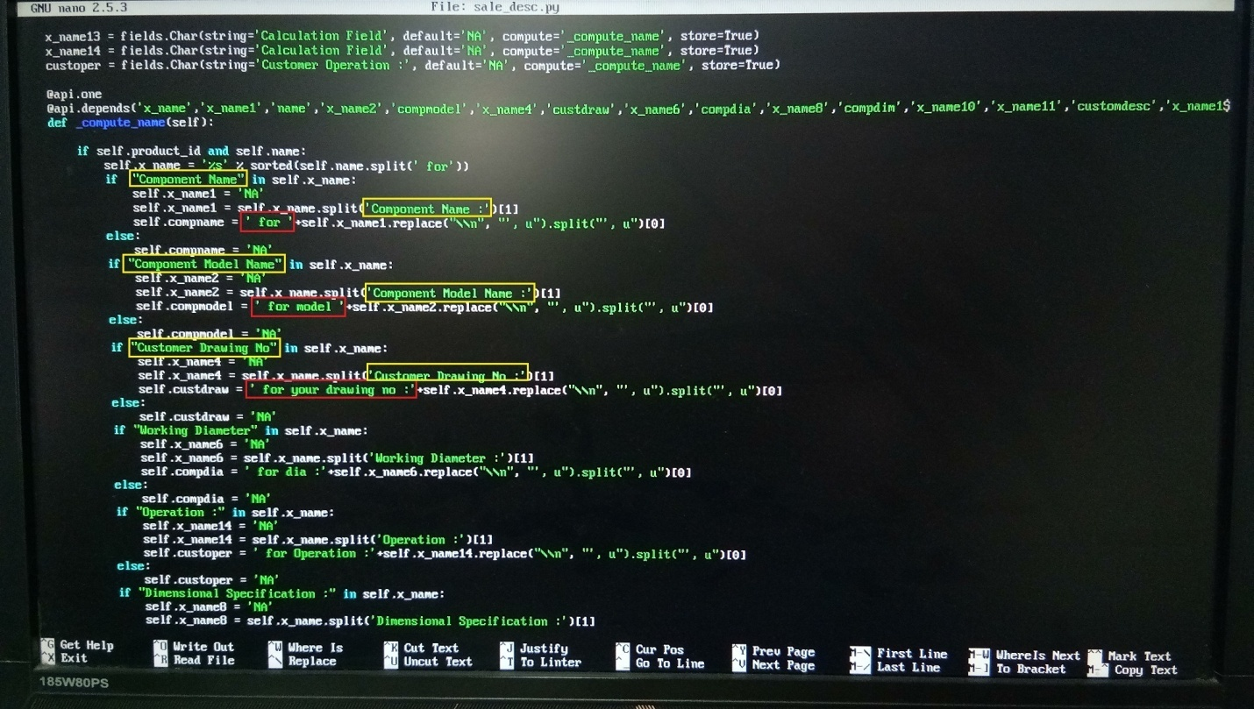

Figure5

You can also customize the text attached to these attributes.

I have Outlined these in Red (Figure5)

**This is the area of the Code that we are looking for (Marked in Red):**

if self.product_id and self.name:

self.x_name = '%s' % sorted(self.name.split(' for'))

if "Component Name" in self.x_name:

self.x_name1 = 'NA'

self.x_name1 = self.x_name.split('Component Name :')[1]

self.compname = ' for '+self.x_name1.replace("\\n", "', u").split("', u")[0]

else:

self.compname = 'NA'

if "Component Model Name" in self.x_name:

self.x_name2 = 'NA'

self.x_name2 = self.x_name.split('Component Model Name :')[1]

self.compmodel = ' for model '+self.x_name2.replace("\\n", "', u").split("', u")[0]

else:

self.compmodel = 'NA'

if "Customer Drawing No" in self.x_name:

self.x_name4 = 'NA'

self.x_name4 = self.x_name.split('Customer Drawing No :')[1]

self.custdraw = ' for your drawing no :'+self.x_name4.replace("\\n", "', u").split("', u")[0]

else:

self.custdraw = 'NA'

**Save this file.**

Log into your Odoo Database.

Now, we are ready to Install this module.

From your browser, update module list. Look for this module. Click on Install.

Should you come across an error “List Index out of range”

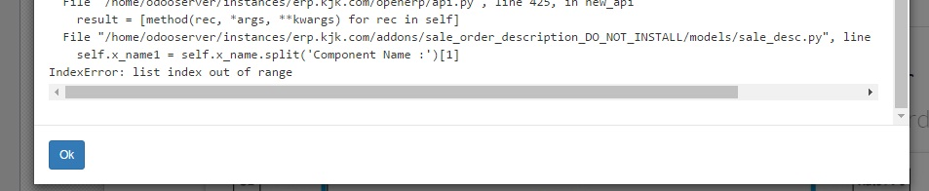

Figure6

Please close the error window. Click on “Cancel Install”

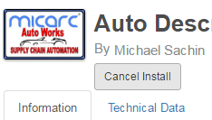

Figure7

Click on “Install”, again.

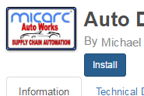

Figure8

And you should be good to go.

Please open your Quotations or Sale Orders now and Add an Item. This is what you should see:

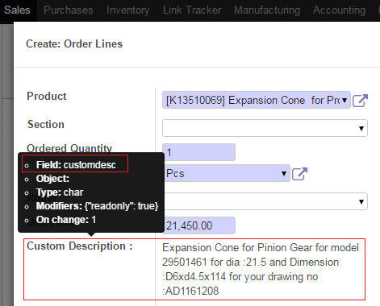

Figure9

Please Note :

The Field “customdesc” Now carries your Customized Description. You can display this in your quotations and sale orders.

How to set this up:

1. Goto – Settings – Reports – Reports

Search for “Quotation”

Click on “Quotation / Order”

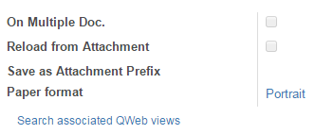

Figure10

Click on “Search associated QWeb views”

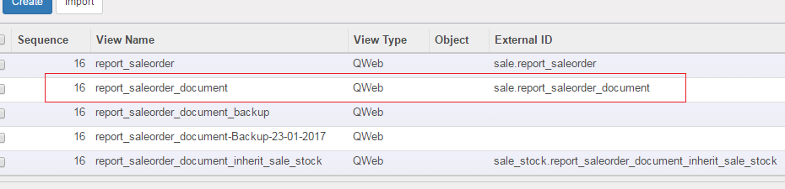

Figure11

Click on report_saleorder_document

Edit.

Look for <span t-field="l.name"/>

Change to <span t-field="l.customdesc"/>

Save.

1. Goto – Settings – User Interface – Views

Search for “layouted”

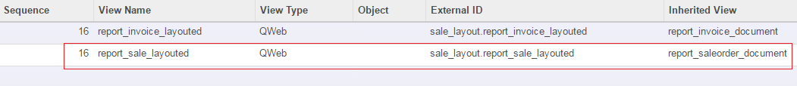

Figure12

Click on “report_sale_layouted”

Edit.

Look for <span t-field="l.name"/>

Change to <span t-field="l.customdesc"/>

Save.

Now, Please print out your Sale Order or Quotations. You should have the updated description there.

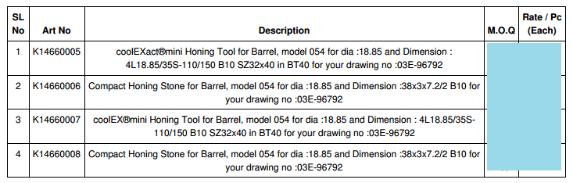

Figure13

ENJOY!

**[** Note: If you are unable to get this working, please feel free to contact me. I will assist you with any errors you may get or if you have any issues looking for something. **]**

**Name : Michael Sachin**

**E-mail :** [**michaelsachin@gmail.com**](mailto:michaelsachin@gmail.com)

**Phone : +91-9962327490 (Chennai - India)**